2026 PROXY FORM
To: Civil Contractors New Zealand Incorporated (CCNZ)
I/we (printed name of person completing this form)
the authorised representative of (member company name)
being a full or life member of CCNZ hereby appoint:
☐ (Name of proxy who will be attending the AGM)
Or
☐ the Chair of the Annual General Meeting or any member of the Executive Council who will be attending the Annual General Meeting (please tick one)
as my/our proxy to vote for me/us on my/our behalf at the Annual General Meeting of CCNZ to be held online on Wednesday 26 August 2026 at 4:00pm and any adjournment thereof.
Unless otherwise directed below, my/our proxy may vote as he/she thinks fit or abstain from voting.
This part of the form is for use as voting instructions for a proxy at the Annual General Meeting. If you wish to, please indicate with a mark in the appropriate box how you wish your vote to be cast by your proxy
VOTE

FOR | AGAINST | ABSTAIN (Indicate with a tick)

Resolution 1 ☐ ☐ ☐
That the minutes of the 81st AGM held on
14 August 2025 be confirmed as true and correct.
Resolution 2 ☐ ☐ ☐
That the CCNZ Annual Report including
the Financial Statements for the period ended
31 March 2026 be approved and adopted.
Resolution 3 ☐ ☐ ☐
That Moore Markhams be appointed
CCNZ’s auditor for the financial year
ending 31 March 2027.
Election of Executive Council
We have received five nominations for three positions. Profiles of the candidates are included in the AGM papers. Please tick the boxes for the candidates you wish your vote to be cast for by your proxy. Tick up to 3 boxes only:
Kylie Bourke, North Drill ☐

Fletcher Cranfield, Wanaka Civil ☐
Mark Evans, HEB Construction ☐
Gavin Riddle, MS Civil Construction ☐
Samantha Riley, Downer NZ ☐
Dated this _______ day of _______
Signed on behalf of _____________________________________

Signature

Position
Please return completed proxy form to:
The Chief Executive, Civil Contractors NZ (Incorporated)
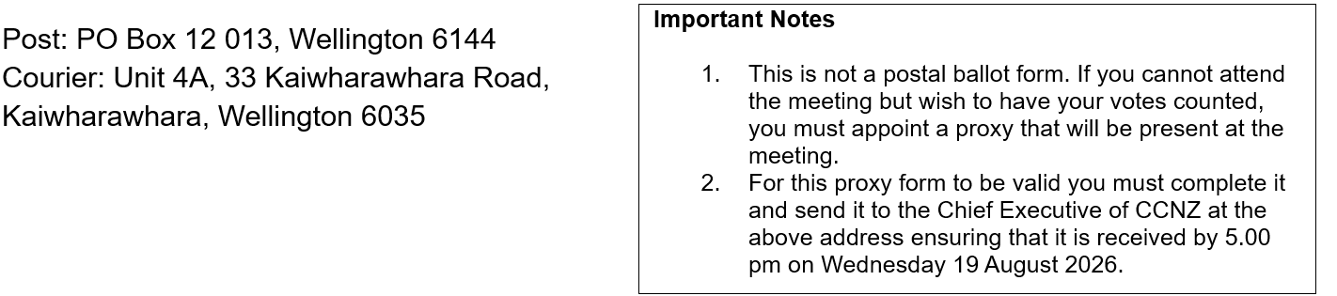
Email: alan@civilcontractors.co.nz

